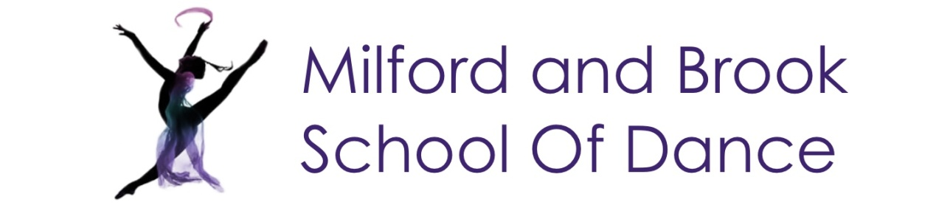
Becky Bradbury B.Phil(hons) , LRAD, ARAD, AISTD
beckybradbury@gmail.com Tel:07891 426346

NEWSLETTER AUTUMN TERM 2020

Dear Parents and Dancers

We are all excited to finally be returning to the studio. However in order to keep everyone safe and to abide by social distancing there will be some key changes.

There will be no changing facilities at the halls and the toilets will only be used if unavoidable.

No parents will enter the buildings. Please wait in the car park for your children

Where possible you will enter the hall through the usual door and collect from a different door.

The last 5 minutes of class will be for cleaning. Please queue to collect your children at the exit door. Cleaning will then be done and students to the next class welcomed at the entrance door.

All students will be asked to hand sanitise on entering and exiting the class.

In some circumstances barres may be replaced by alternatives to accommodate social distancing.

2m squares will be chalked on the floor to aid social distancing.

Babies and Pre Primary children have been given personal props handmade by Mis Rebecca, please bring them with you as we cannot allow sharing of props.

Babies, Pre Primary and Primary are asked to bring a small hand towel or similar sized mat for the sitting exercises.

Please being everything you need for class into the hall with you in a bag.

I will wear a face visor as I interact with so many different classes and have to project my voice. No one is required to wear a mask or visa but if you wish to due to your own circumstances please feel very welcome.

As we will have less opportunity to speak to parents do please give us a call if you need any further information.

Miss Becky 07891 426346 Miss Rebecca 07884 264949

